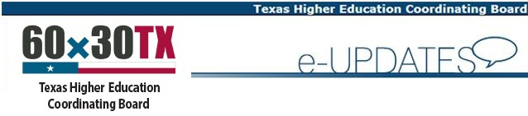
This email message is being sent on behalf of Claudette Jenks, Assistant Director, Division of College Readiness and Success, Texas Higher Education Coordinating Board

REGISTER NOW
Registration Fee increases after May 31!

2017 P-16 Statewide Professional Development Conference

Thursday, June 29, 2017

DoubleTree Hotel
6505 IH-35 North
Austin, Texas 78752

Are you interested in learning more about college access and success across Texas? Then be sure to join us on June 29, 2017, in Austin, for the annual P-16 Statewide Professional Development Conference hosted by the Texas Higher Education Coordinating Board Division of College Readiness and Success. This event is intended to bridge secondary and postsecondary education and support the THECB's goals of the 60x30TX strategic plan. High school counselors, admissions advisors from two-year and four-year institutions, and other educators interested in learning more about college access and success across Texas are invited to attend.
This event is eligible for CPE credit through the Texas Higher Education Coordinating Board.
The conference will be held at the DoubleTree Hotel, 6505 IH-35 North, Austin, Texas 78752.
Conference Agenda
8:00 - 9:00 a.m. | Registration/Continental Breakfast
9:00 - 10:00 a.m. | General Session
10:15 - 11:00 a.m. | Concurrent Sessions
11:15 a.m. - 12:00 p.m. | Concurrent Sessions
12:15 - 1:30 p.m. | Lunch and Plenary Session
1:45 - 2:30 p.m. | Concurrent Sessions
2:15 - 3:30 p.m. | Closing Session

Conference Lodging Policy
- Lodging at the conference for the night of June 28, 2017 will be provided on a first come, first served basis by THECB.
- Any additional hotel expenses beyond cost of one night room rate (i.e. additional nights lodging, incidentals) are the responsibility of the attendee.
- Lodging is reserved for participants who are located 45 miles or more from the conference hotel, based on their main office or work location.
- Lodging must be requested by June 1, 2017.
- Lodging is not guaranteed.
- Accelerate Texas grantees and affiliates do not qualify for no cost lodging and must make arrangements directly with hotel.
- You will receive a notice from Texas Higher Education Coordinating Board staff to confirm lodging arrangements and next steps.
Registration Fees
Regular Registration (Valid through May 31) | $150
Late Registration (June 1 - June 29) | $175
Presenters (selected and notified by THECB) | $0

