2015 Gap Analysis for the North Texas Region

North Texas Regional P-16 Council
Fall, 2016

Table of Contents
Our Mission 3
Our Goals 3
Purpose of the Gap Analysis Reports 3
Executive Summary of the 2015 Report 4
Notes on Reading the Data Presentations 5
Geographic and Demographic Parameters 6
College Readiness Scorecard 10
Higher Education Enrollment Scorecard 313
Developmental Education Accountability Scorecard 444
College Completion, Employment, and Student Debt Scorecard 533

Our Mission
The North Texas Regional P-16 Council provides networking and collaborating opportunities across all levels of education along with families, businesses, workforce systems, faith-based groups, local, state, and federal agencies, and philanthropic and community organizations to advance the education of all students and to close the gaps in students' academic access and achievements.

Our Goals
The North Texas Regional P-16 Council will:
- support educational and community initiatives that create a college-going culture, especially among students from underrepresented groups in higher education;
- develop collaborative relationships and resources that promote education and produce educated citizens who are workforce ready;
- support the development of educators who understand and promote the diverse needs of communities and workplaces; and
- increase understanding of educational transitional and career pathways among students, families, educators, and leaders.

Purpose of the Gap Analysis Reports
The gap analysis reports, first issued by the North Texas Regional P-16 Council in 2003, offer analysis of data that explicate the achievement of students in the region and gaps in their achievement that must be addressed. Using Texas Education Agency (TEA) and Texas Higher Education Coordinating Board (THECB) data, which depend on data collected from members, the reports contribute to evaluation of regional progress in closing student achievement gaps. They provide a longitudinal picture of progress on key measures as a basis for strategic planning of the Council to address its goals. The geographic region addressed includes the similar Metroplex Region of THECB and Education Service Centers 10 and 11 as reported by TEA or the continuous Collin, Dallas, Denton, and Tarrant Counties.

Executive Summary of the 2015 Report
In spite of rapid increases in the ethnic diversity of the region, Whites are expected to remain the largest ethnic group among its young adult population through 2020 in a state with a Hispanic majority for the 18 to 35 age group.
The 2015 report offers longitudinal data going back to 2006 for college readiness indicators pertaining to regional high school graduates through the 2014-15 school year. Data about college readiness measured by TAKS/STAAR scores of graduates in English Language Arts, mathematics and both subjects, SAT/ACT results, advanced course/dual enrollment completion, and Free Application for Federal Student Aid (FAFSA) showed patterns of progress similar for the state of Texas and the North Texas region.
Scores for students of the region on the state TAKS/STAAR assessments in English Language Arts, mathematics, and both subjects have increased over time, and regional student scores tend to be higher than state averages. Gaps in the achievement of ethnic, gender, and socioeconomic subgroups are apparent, however, in spite of subgroup gains. Notable in the 2014-15 data were drops in mathematics scores in the state and region sufficient to reverse, for this one year, a rising trend for this subject.
SAT/ACT trend data showed almost no increases in percentages of students taking the tests in the state or region. The percentages of students meeting or exceeding the passing criteria for the tests tended to be higher for students in the region than for those in the state. Trend data show slight gains in ACT and decreases in SAT scores over time.
Currently, more than 33% of high school students in that state and region enroll in advanced courses, which includes dual enrollment. Percentages of high school students enrolled in advanced courses/dual enrollment have increased by about 13% in the state and region since 2003, with the rate of regional enrollment exceeding that of the state. Breaking out dual credit enrollment since 2009 showed the region lagged behind the state on this college readiness measure. Instead, AP/IB courses were more likely to be taken by students in the North Texas region, compared to those of the state.
This year’s report includes FAFSA completion data. In both the state and region, although about 53% of seniors completed applications but fewer than 49% were complete.
Since 1996, the number of students enrolled in higher education in Dallas, Denton, Collin, and Tarrant counties has more than doubled, with an average of 50% of students going on to college immediately after high school graduation. In spite of increasing college enrollment for all subgroups, there are gaps for African American and Hispanic compared to White students, for males compared to females, and for socioeconomically disadvantaged students.
Students who enter college not requiring developmental education are more likely to graduate or to persist in their programs than those requiring developmental education. However, students in the region who entered 4-year colleges not requiring developmental education were less likely to graduate than those of the state, in general. Although lower percentages of students in the region who entered 2-year and 4-year colleges required developmental education than comparable students across the state, more than half of regional students who entered 2-year colleges required developmental education.
Of high school graduates who entered postsecondary education in the region, 27% completed a degree or certificate within 6 years, which is similar to state data. From 2009 to 2014, the employment rate for regional graduates of 2-year colleges was about 71% and for 4-year colleges, about 73%. The employment picture in terms of employment rate and mean wage was slightly better for students in the region than in the state.

Notes on Reading the Data Presentations
Most of the data in this report are presented longitudinally in tables and graphs. Tables typically present chronological data by year from the oldest collected by the North Texas Regional P-16 Council to the most recent. Our focus, whenever possible, is on the Mean Annual Rate of Change (MARC) for the years presented. MARC enables us to answer questions about trends in the performance of the group represented on a particular measure over time. The direction of the trend for each column is indicated by the color of the MARC, green for improving, red for declining, and yellow for constant. Line graphs augment the tables by presenting longitudinal data for the state and for ESC 10 and ESC 11. In reading these graphs, please note that in order to save space, the x-axis generally ranges from 15% to 85%, not presenting the full range of possible scores.
Our purpose in presenting regional data is to compare indicators for students in North Texas to those of the State. It was not possible to combine the data for ESC 10 and ESC 11 using the statistics available, so they had to be presented separately.
Readers of earlier gap analysis reports will note changes in the state accountability systems used by the TEA and the THECB over time. These changes pertain to the assessments employed and the way their results and other school data are reported. This 2015 report includes information about high school student performance based on the Texas Assessment of Knowledge and Skills (TAKS) through 2011-2012 and the State of Texas Assessment of Academic Readiness (STAAR) and End of Course (EOC) tests, effective 2012-13 although these are not directly comparable. In the 2012-2013 school year, the Texas Academic Performance Reports (TAPR) replaced the Academic Excellence Indicator System (AEIS) used since 1990-1991, to report K-12 data. Detailed information about differences between the two state assessment systems is included in the 2013 Gap Analysis Report.

Geographic and Demographic Parameters

Texas Higher Education Coordinating Board Regions

(Region 3 – Metroplex is highlighted)
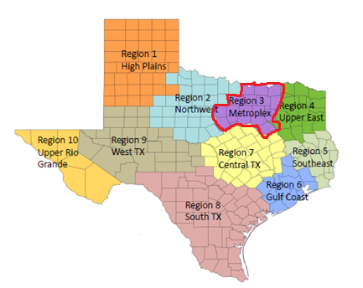
Note: Region 3 of THECB includes the entire ESC 10 and the majority of ESC 11 of TEA.

Region 3 Public and Private Institutions of Higher Education
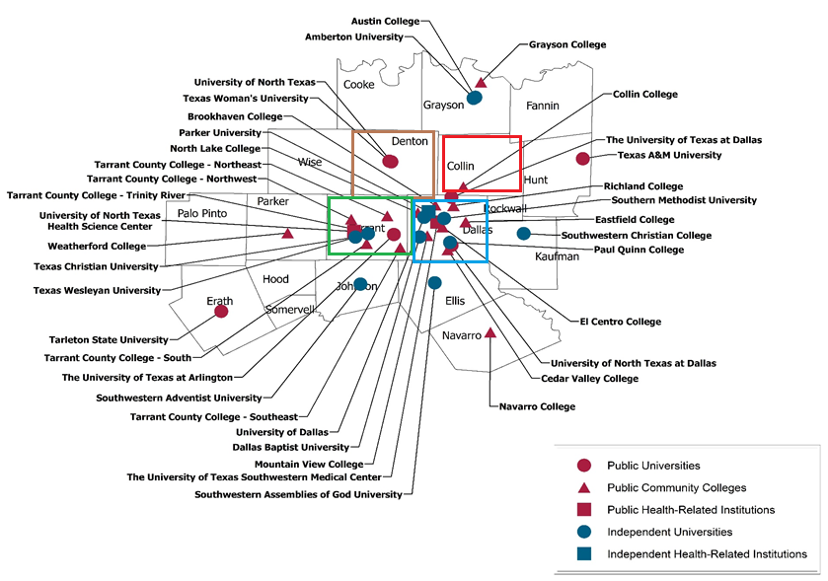

Texas Education Agency Regions (Education Service Centers 10 and 11 are highlighted)

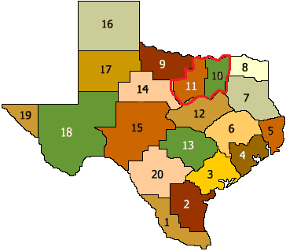

Municipal Counties in Education Service Centers (ESCs) 10 and ESC 11

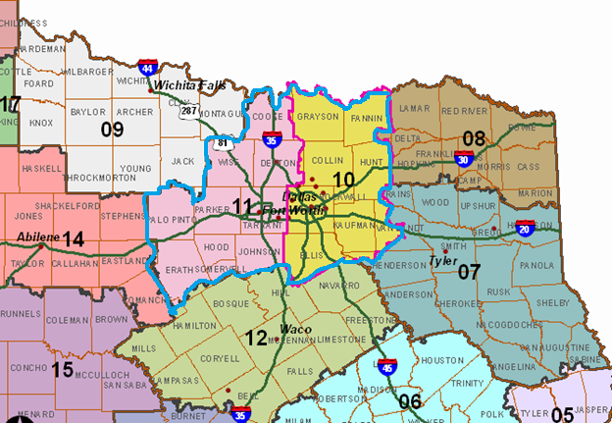
Note: There are eight counties in ESC 10 (Collin, Dallas, Ellis, Fannin, Grayson, Hunt, Kaufman, and Rockwall) and nine in ESC 11 (Cooke, Denton, Erath, Hood, Johnson, Palo Pinto, Parker, Tarrant, Wise). Navarro County is not part of ESC 10 or 11 but is a part of THECB Region 3.

2000 and 2010 Populations and 2015 and 2020 Projections in State and Region 3 by Ethnicity (Ages 18 – 35 only)
Year/Δ | State |  |  |  | Region 3
 | White | African American | Hispanic |  | White | African American | Hispanic
2020 | 2,481,446 | 864,728 | 3,419,255 |  | 747,006 | 286,901 | 711,682
2015 | 2,569,212 | 837,650 | 3,069,275 |  | 768,460 | 272,833 | 624,887
2010 | 2,577,006 | 790,025 | 2,744,451 |  | 769,938 | 256,712 | 565,789
2000 | 2,619,380 | 690,025 | 2,159,137 |  | 820,391 | 216,384 | 440,050
Δ | 3.7% | 9.4% | 23.2% |  | 3.0% | 11.8% | 25.8%
(Source: THECB – Texas Higher Education Regional Data – 2010, 2012, 2015)
Note 1: Δ = Difference between 2020 and 2010.
Note 2: The Metroplex region includes 18 counties in north Texas.

For adults in the 18-35 age range, the North Texas Region is changing faster than the state in the percentage of increase of African American and Hispanic young adults, with corresponding decreases in the percentage of White young adults. By 2020, although Whites are expected to remain the largest ethnic group among young adults in the North Texas Region, the majority ethnicity for this age group in the state is and will continue to be Hispanic.

College Readiness Scorecard
Since 2006, Texas students have made substantial and almost always continuous gains in their extent of college readiness as measured by TAKS/STAAR scores in English language arts (ELA), mathematics, and both subjects. In spite of this, drops in English language arts scores were seen for students in all groups from 2012 to 2013. Although this pattern was reversed in 2014-15, mathematics scores dropped for students in all groups, and any gains were not substantial enough to positively impact scores in both subjects for some subgroups. The North Texas region has often outperformed the state in percentages of students whose TAKS/STAAR scores indicated they were college ready in ELA, mathematics, and both subjects. In 2014-15, 54% of students in the state, 57% of students in ESC Region 10, and 68% of students in ESC Region 11 met the criteria for college readiness in both subjects. Regional data are similar to those for the state when scores are examined by ethnicity and gender. Gaps for African American and Hispanic students, compared to White students, tended to close over time but were still very evident in 2014-15 on all three measures. Females of the state and region performed better than males in ELA, mathematics, and both subjects, a change in an earlier trend toward superior performance for males in mathematics.

College-Ready High School Graduates in English Language Arts, Mathematics, and Both Subjects and Mean Annual Rate of Change from 2006 to 2014 in State, ESC 10, and ESC 11
Year/  MARC | State |  |  |  | ESC 10 |  |  |  | ESC 11
 | ELA | Math | Both Subjects |  | ELA | Math | Both Subjects |  | ELA | Math | Both Subjects
2006 | 48% | 52% | 35% |  | 53% | 54% | 39% |  | 51% | 55% | 39%
2007 | 49% | 56% | 37% |  | 52% | 57% | 40% |  | 53% | 59% | 42%
2008 | 59% | 58% | 44% |  | 62% | 61% | 48% |  | 62% | 61% | 48%
2009 | 62% | 60% | 47% |  | 64% | 62% | 50% |  | 65% | 63% | 51%
2010 | 66% | 64% | 52% |  | 68% | 67% | 55% |  | 71% | 67% | 57%
2011 | 64% | 67% | 52% |  | 67% | 69% | 55% |  | 68% | 70% | 56%
2012 | 69% | 70% | 57% |  | 73% | 73% | 61% |  | 73% | 71% | 59%
2013 | 65% | 74% | 56% |  | 68% | 77% | 59% |  | 69% | 76% | 60%
2014 | 68% | 67% | 54% |  | 71% | 70% | 58% |  | 71% | 69% | 57%
Δ | 3% | 7% | 2% |  | 3% | 7% | 1% |  | 2% | 7% | 3%
MARC | 2.5% | 2.4% | 2.7% |  | 2.4% | 2.6% | 2.7% |  | 2.6% | 2.2% | 2.6%
(Source: Texas Education Agency - AEIS 2007 – 2012; TAPR 2012-13, 2013-14, 2014-15)
Note 1: ELA = English Language Arts, Math = Mathematics
Note 2: Δ = Change from 2013 to 2014; MARC = Mean Annual Rate of Change from 2006 to 2014

College-Ready High School Graduates in English Language Arts and Mean Annual Rate of Change from 2006 to 2014 in State, ESC 10, and ESC 11 by Ethnicity
Year/  MARC | State |  |  |  | ESC 10 |  |  |  | ESC 11
 | African Amer. | Hispanic | White |  | African Amer. | Hispanic | White |  | African Amer. | Hispanic | White
2006 | 33% | 36% | 59% |  | 36% | 35% | 64% |  | 34% | 36% | 58%
2007 | 34% | 38% | 59% |  | 35% | 35% | 64% |  | 37% | 39% | 59%
2008 | 44% | 48% | 70% |  | 47% | 48% | 74% |  | 45% | 48% | 70%
2009 | 49% | 52% | 72% |  | 49% | 51% | 76% |  | 51% | 51% | 72%
2010 | 53% | 58% | 77% |  | 54% | 57% | 80% |  | 55% | 60% | 79%
2011 | 52% | 55% | 74% |  | 54% | 56% | 78% |  | 55% | 56% | 76%
2012 | 58% | 62% | 79% |  | 61% | 65% | 83% |  | 61% | 62% | 80%
2013 | 53% | 58% | 75% |  | 55% | 60% | 79% |  | 58% | 60% | 76%
2014 | 56% | 62% | 77% |  | 59% | 64% | 81% |  | 57% | 63% | 77%
Δ | 3% | 4% | 2% |  | 4% | 4% | 2% |  | 1% | 3% | 1%
MARC | 3.0% | 3.3% | 2.3% |  | 3.1% | 3.8% | 2.2% |  | 3.2% | 3.4% | 2.5%
(Source: Texas Education Agency - AEIS 2007 – 2012; TAPR 2012-13, 2013-14, 2014-15)

Note: Δ = Change from 2013 to 2014; MARC = Mean Annual Rate of Change from 2006 to 2014

College-Ready High School Graduates in Mathematics and Mean Annual Rate of Change from 2006 to 2014 in State, ESC 10, and ESC 11 by Ethnicity

Year/  MARC | State |  |  |  | ESC 10 |  |  |  | ESC 11
 | African Amer. | Hispanic | White |  | African Amer. | Hispanic | White |  | African Amer. | Hispanic | White
2006 | 29% | 39% | 64% |  | 30% | 38% | 67% |  | 31% | 38% | 63%
2007 | 33% | 45% | 66% |  | 33% | 46% | 69% |  | 33% | 47% | 65%
2008 | 37% | 48% | 70% |  | 37% | 48% | 74% |  | 36% | 49% | 69%
2009 | 41% | 50% | 71% |  | 41% | 52% | 75% |  | 40% | 50% | 70%
2010 | 46% | 57% | 75% |  | 48% | 58% | 79% |  | 46% | 57% | 76%
2011 | 50% | 60% | 78% |  | 51% | 62% | 81% |  | 49% | 59% | 78%
2012 | 55% | 64% | 79% |  | 57% | 67% | 83% |  | 51% | 62% | 78%
2013 | 60% | 69% | 83% |  | 63% | 71% | 86% |  | 59% | 68% | 83%
2014 | 51% | 62% | 78% |  | 54% | 63% | 81% |  | 48% | 61% | 77%
Δ | 9% | 7% | 5% |  | 9% | 8% | 5% |  | 11% | 7% | 6%
MARC | 3.6% | 3.4% | 2.2% |  | 3.9% | 3.7% | 2.2% |  | 3.1% | 3.2% | 2.3%
(Source: Texas Education Agency - AEIS 2007 – 2012; TAPR 2012-13, 2013-14, 2014-15)
Note: Δ = Change from 2013 to 2014; MARC = Mean Annual Rate of Change from 2006 to 2014

College-Ready High School Graduates in Both English Language Arts and Mathematics and Mean Annual Rate of Change from 2006 to 2014 in State, ESC 10, and ESC 11 by Ethnicity
Year/  MARC | State |  |  |  | ESC 10 |  |  |  | ESC 11
 | African Amer. | Hispanic | White |  | African Amer. | Hispanic | White |  | African Amer. | Hispanic | White
2006 | 16% | 21% | 48% |  | 18% | 20% | 53% |  | 17% | 21% | 46%
2007 | 19% | 25% | 49% |  | 19% | 24% | 53% |  | 20% | 27% | 48%
2008 | 25% | 32% | 57% |  | 26% | 31% | 62% |  | 30% | 35% | 59%
2009 | 29% | 35% | 60% |  | 29% | 36% | 65% |  | 25% | 32% | 56%
2010 | 34% | 42% | 66% |  | 35% | 42% | 70% |  | 34% | 43% | 67%
2011 | 36% | 42% | 65% |  | 37% | 43% | 69% |  | 36% | 42% | 66%
2012 | 41% | 48% | 69% |  | 44% | 51% | 75% |  | 40% | 47% | 69%
2013 | 41% | 48% | 69% |  | 43% | 49% | 73% |  | 43% | 49% | 69%
2014 | 38% | 47% | 67% |  | 41% | 48% | 72% |  | 36% | 46% | 67%
Δ | 3% | 1% | 2% |  | 2% | 1% | 1% |  | 7% | 3% | 2%
MARC | 3.2% | 3.5% | 2.8% |  | 3.5% | 3.9% | 2.8% |  | 3.0% | 3.4% | 3.0%
(Source: Texas Education Agency - AEIS 2007 – 2012; TAPR 2012-13, 2013-14, 2014-15)
Note: Δ = Change from 2013 to 2014; MARC = Mean Annual Rate of Change from 2006 to 2014

*State data are identical with ESC Region 11 date in 2012, 2013, and 2014.

College-Ready High School Graduates in English Language Arts and Mean Annual Rate of Change from 2006 to 2014 in State, ESC 10, and ESC 11 by Gender
Year/  MARC | State |  |  | ESC 10 |  |  | ESC 11
 | Male | Female |  | Male | Female |  | Male | Female
2006 | 43% | 53% |  | 48% | 57% |  | 46% | 56%
2007 | 44% | 54% |  | 47% | 56% |  | 49% | 58%
2008 | 55% | 63% |  | 59% | 65% |  | 59% | 65%
2009 | 58% | 66% |  | 60% | 67% |  | 62% | 68%
2010 | 62% | 70% |  | 64% | 71% |  | 68% | 75%
2011 | 60% | 67% |  | 63% | 70% |  | 65% | 72%
2012 | 65% | 73% |  | 69% | 77% |  | 68% | 77%
2013 | 60% | 70% |  | 63% | 72% |  | 64% | 74%
2014 | 63% | 73% |  | 66% | 75% |  | 66% | 75%
Δ | 3% | 3% |  | 3% | 3% |  | 2% | 1%
MARC | 2.5% | 2.5% |  | 2.4% | 2.5% |  | 2.4% | 2.5%
(Source: Texas Education Agency - AEIS 2007 – 2012; TAPR 2012-13, 2013-14, 2014-15)
Note: Δ = Change from 2013 to 2014; MARC = Mean Annual Rate of Change from 2006 to 2014

College-Ready High School Graduates in Mathematics and Mean Annual Rate of Change from 2006 to 2014 in State, ESC 10, and ESC 11 by Gender
Year/  MARC | State |  |  | ESC 10 |  |  | ESC 11
 | Male | Female |  | Male | Female |  | Male | Female
2006 | 56% | 47% |  | 58% | 50% |  | 60% | 51%
2007 | 59% | 52% |  | 61% | 54% |  | 63% | 55%
2008 | 63% | 54% |  | 65% | 56% |  | 66% | 57%
2009 | 62% | 58% |  | 65% | 60% |  | 65% | 60%
2010 | 66% | 62% |  | 69% | 65% |  | 70% | 65%
2011 | 69% | 66% |  | 71% | 68% |  | 72% | 68%
2012 | 71% | 69% |  | 74% | 72% |  | 72% | 69%
2013 | 75% | 73% |  | 78% | 75% |  | 78% | 74%
2014 | 69% | 66% |  | 72% | 68% |  | 71% | 67%
Δ | 6% | 7% |  | 6% | 7% |  | 7% | 7%
MARC | 2.1% | 3.0% |  | 2.2% | 2.9% |  | 1.8% | 2.6%
(Source: Texas Education Agency - AEIS 2007 – 2012；TAPR 2012-13, 2013-14, 2014-15)
Note: Δ = Change from 2013 to 2014; MARC = Mean Annual Rate of Change from 2006 to 2014

College-Ready High School Graduates in both English Language Arts and Mathematics and Mean Annual Rate of Change from 2006 to 2014 in State, ESC 10, and ESC 11 by Gender
Year/  MARC | State |  |  | ESC 10 |  |  | ESC 11
 | Male | Female |  | Male | Female |  | Male | Female
2006 | 34% | 36% |  | 39% | 40% |  | 38% | 39%
2007 | 36% | 38% |  | 40% | 41% |  | 41% | 42%
2008 | 45% | 44% |  | 49% | 46% |  | 49% | 48%
2009 | 46% | 48% |  | 50% | 50% |  | 50% | 51%
2010 | 51% | 53% |  | 54% | 55% |  | 57% | 58%
2011 | 50% | 53% |  | 53% | 56% |  | 55% | 57%
2012 | 55% | 58% |  | 60% | 63% |  | 58% | 61%
2013 | 53% | 59% |  | 57% | 62% |  | 58% | 63%
2014 | 52% | 56% |  | 56% | 59% |  | 56% | 58%
Δ | 1% | 3% |  | 1% | 3% |  | 2% | 5%
MARC | 2.5% | 2.9% |  | 2.4% | 3.0% |  | 2.4% | 2.9%
(Source: Texas Education Agency - AEIS 2007 – 2012; TAPR 2012-13, 2013-14, 2014-15)
Note: Δ = Change from 2013 to 2014; MARC = Mean Annual Rate of Change from 2006 to 2014

Considered as a college readiness measure, SAT/ACT performance shows very modest increases for the state and region in percentages of students taking these tests from 1996 to 2014 with participation and scores for students in the region exceeding those of the state on all measures in 2014. Students in the region exceeded those of the state in the percentages scoring at or above the passing criteria on both tests. Trend data showed slight gains in scores on the ACT and decreases in scores on the SAT over time with deviation from this pattern in ESC 10.

SAT/ACT Results of High School Students and Mean Annual Rate of Change from 1996 to 2014 in State, ESC 10, and ESC 11
Year/  MARC | State |  |  |  | ESC 10 |  |  |  | ESC 11
 | % of  Students Taking  SAT/ACT | Percent >=  Criteria | SAT/ACT  Score |  | % of  Students Taking  SAT/ACT | Percent >=  Criteria | SAT/ACT  Score |  | % of  Students Taking  SAT/ACT | Percent >=  Criteria | SAT/ACT  Score
1996 | 65% | 26% | 992/20.1 |  | 66% | 31% | 1011/20.5 |  | 67% | 32% | 1015/21.0
1997 | 64% | 27% | 993/20.1 |  | 65% | 32% | 1010/20.7 |  | 65% | 31% | 1017/21.0
1998 | 62% | 27% | 992/20.3 |  | 64% | 33% | 1016/21.1 |  | 65% | 31% | 1019/21.0
1999 | 62% | 27% | 989/20.2 |  | 64% | 32% | 1013/20.9 |  | 65% | 33% | 1020/21.2
2000 | 62% | 27% | 990/20.3 |  | 64% | 33% | 1012/21.0 |  | 64% | 33% | 1021/21.2
2001 | 63% | 27% | 987/20.2 |  | 62% | 32% | 1008/21.0 |  | 65% | 32% | 1020/21.0
2002 | 62% | 27% | 986/20.0 |  | 61% | 32% | 1009/20.8 |  | 63% | 32% | 1017/20.8
2003 | 62% | 27% | 989/19.9 |  | 61% | 33% | 1009/20.8 |  | 64% | 32% | 1021/20.8
2004 | 62% | 27% | 987/20.1 |  | 60% | 32% | 1008/20.9 |  | 63% | 33% | 1023/21.1
2005 | 66% | 27% | 992/20.0 |  | 65% | 32% | 1008/20.8 |  | 66% | 34% | 1029/21.0
2006 | 66% | 27% | 991/20.2 |  | 66% | 33% | 1011/21.1 |  | 67% | 33% | 1025/21.2
2007 | 68% | 27% | 992/20.1 |  | 68% | 32% | 1012/21.1 |  | 69% | 33% | 1023/21.3
2008 | 65% | 27% | 987/20.5 |  | 64% | 33% | 1011/21.3 |  | 65% | 34% | 1019/21.6
2009 | 62% | 27% | 985/20.5 |  | 61% | 32% | 1007/21.3 |  | 62% | 34% | 1021/21.8
2010 | 63% | 27% | 985/20.5 |  | 64% | 32% | 1000/21.4 |  | 64% | 35% | 1020/22.0
2011 | 69% | 26% | 976/20.5 |  | 71% | 30% | 986/21.2 |  | 70% | 33% | 1010/21.9
2012 | 67% | 25% | 966/20.5 |  | 69% | 30% | 985/21.3 |  | 66% | 32% | 1006/21.9
2013 | 63.8% | 25.4% | 967/20.6 |  | 65.9% | 30.3% | 982/21.3 |  | 62.9% | 32.9% | 1004/21.8
2014 | 66.3% | 25.1% | 961/20.6 |  | 67.0% | 30.1% | 985/21.2 |  | 68.4% | 31.2% | 986/21.9
Δ | 2.5% | 0.3% | 6 / .00 |  | 1.1% | 0.2% | 3.0/ 0.1 |  | 5.5% | 1.7% | 18/ 0.1
MARC | 0.2% | 0.1% | 1.4/ .03 |  | 0.2% | 0.1% | 1.6/ .03 |  | 0.1% | 0.1% |  | 0.9/ .06
(Source: Texas Education Agency - AEIS 2007 – 2012; TAPR 2012-13, 2013-14, 2014-15, Personal communication with Rona Tong and Jonathan West at TEA on the SAT scores)
Note 1: Δ = Change from 2013 to 2014; MARC = Mean Annual Rate of Change from 1996 to 2014
Note 2: To be consistent with the data in 2011 and earlier, the SAT scores from 2012 to 2014 do not include the part on writing.

The North Texas region was similar to or slightly exceeded the state in percentages of high school students who enrolled in and completed at least one advanced course. In the TAPR/AEIS reports, advanced courses include AP/IB, dual credit, and other courses identified by the TEA. Between 2003 and 2014, the percentages of high school students in the region completing advanced courses increased from about 20% to 34.5% in ESC 10 and 33.2% in ESC 11. Splitting out the percentages of high school students completing dual credit courses in these same years (See page 27.) shows that the region lags well behind the state in percentage of students participating in this type of advanced course. Instead, students in the region are more likely to enroll in AP/IB courses and programs, which may indicate greater interest among students of the region in attending out-of-state institutions of higher education.

Advanced Course/Dual Enrollment Completion of High School Students and Mean Annual Rate of Change from 2003 to 2014 in State, ESC 10, and ESC 11
Year/MARC | State |  | ESC 10 |  | ESC 11
2003 | 19.7% |  | 20.7% |  | 19.8%
2004 | 19.9% |  | 20.9% |  | 20.6%
2005 | 20.5% |  | 20.9% |  | 21.6%
2006 | 21.0% |  | 22.3% |  | 22.0%
2007 | 22.1% |  | 23.4% |  | 22.9%
2008 | 23.1% |  | 24.5% |  | 24.1%
2009 | 24.6% |  | 26.5% |  | 25.1%
2010 | 26.3% |  | 27.9% |  | 26.8%
2011 | 30.3% |  | 32.0% |  | 31.1%
2012 | 30.6% |  | 32.0% |  | 31.3%
2013 | 31.4% |  | 32.5% |  | 32.1%
2014 | 33.1% |  | 34.5% |  | 33.2%
Δ | 1.7% |  | 2.0% |  | 1.1%
MARC | 1.3% |  | 1.4% |  | 1.3%
(Source: Texas Education Agency - AEIS 2004 – 2012; TAPR 2012-13, 2013-14, 2014-15)
Note 1: Δ = Change from 2013 to 2014; MARC = Mean Annual Rate of Change from 2003 to 2014
Note 2: Advanced Course/Dual Enrollment Completion - This indicator is based on a count of students who completed and received credit for at least one advanced course in grades 9−12.

High School Students Enrolled in Dual Credit and Mean Annual Rate of Change from 2009 to 2014 in State and Region 3
Year/Δ | State |  |  |  | Region 3
 | Total HS Graduates | Dual Credit Students | Percent of Dual Credit Students |  | Total HS Graduates | Dual Credit Students | Percent of Dual Credit Students
2009 | 264,275 | 91,303 | 34.5% |  | 69,130 | 12,949 | 18.7%
2010 | 280,520 | 90,364 | 32.2% |  | 71,259 | 14,969 | 21.0%
2011 | 290,581 | 94,550 | 32.5% |  | 76,023 | 16,640 | 21.9%
2012 | 292,636 | 99,454 | 34.0% |  | 77,956 | 16,843 | 21.6%
2013 | 301,418 | 107,598 | 35.7% |  | 80,970 | 21,163 | 26.6%
2014 | 303,109 | 112,361 | 37.1% |  | 82,429 | 23,071 | 28.0%
Δ | 0.6% | 4.4% | 1.4% |  | 1.8% | 9.0% | 1.4%
MARC | 2.8% | 5.6% | 0.7% |  | 4.2% | 18.6% | 1.8%
(Source: THECB – Dual Credit Report, 2009, 2011; Personal Communication with Julie Eklund/Doug Bond at THECB for the 2010, 2012, 2013, 2014 data)
Note 1: Δ = Change from 2013 to 2014; MARC = Mean Annual Rate of Change from 2009 to 2014
Note 2: The MARC for the total HS graduates and dual credit students is calculated as the ratio of the slope over the intercept of the linear equation.

Note 1: Δ = Change from 2012 to 2013
Note 2: The data in 2013 are the most recent ones by the time of this writing in Sept 2016.
Recently, the state has begun to urge schools and regions to collect rates of FAFSA (Free Applications for Federal Student Aid) completion as a measure of college readiness. FAFSA completion indicates both intention to attend college and student concern about managing debt, both related to indicators in the 60x30TX strategic. Data reflect that FAFS completion rates in the state and region are similar, more than 53%, although fewer than 50% of the applications submitted were complete.

FAFSA Submission and Completion Rates in 2015 and 2016 in State and Regions 10 and 11

Year | State |  |  |  |  | ESCs 10 and 11
 | Senior Counts | Submission % | Completion % | Incompletion % |  | Senior Counts | Submission % | Completion % | Incompletion %
2016 | 318,822 | 52.77% | 49.16% | 3.61% |  | 85,955 | 52.35% | 48.38% | 3.97%
2015 | 308,922 | 53.05% | 49.25% | 3.80% |  | 83,882 | 53.55% | 49.44% | 4.11%
Δ | 3.11% | 0.53% | 0.09% | 0.19% |  | 2.41% | 2.29% | 1.06% | 0.14%
(Source: Personal Communications with Dr. Denise Davis at Communities Foundation of Texas)
Note: Δ = Change from 2015 to 20

Higher Education Enrollment Scorecard

Numbers of students enrolled in higher education have increased substantially in the four North Texas Counties of interest between 1996 and 2015. This growth trend is evident in every county but especially in Collin and Denton Counties, which are among the fastest growing counties in the United States. Enrollment growth was more consistent for 4-year than 2-year colleges in all four counties. Notable on the table is growth in the number of not-found students. This statistic includes students enrolled in college out of state or at private institutions as well as those not enrolled in higher education.

High School Graduates Enrolled in Texas Higher Education and Mean Annual Rate of Change from 1996 to 2015 in Four North Texas Counties
Year/  MAD/  MARC | North Texas (Aggregate of Collin, Dallas, Denton, Tarrant Counties)
 | 2-Year | 4-year | Not Trackable | Not Found | Total
1996 | 9,883 | 6,903 | 2,364 | 11,671 | 30,821
1997 | 10,647 | 6,996 | 2,176 | 13,044 | 32,863
1998 | 10,847 | 7,322 | 2,418 | 14,451 | 35,038
1999 | 11,472 | 7,523 | 3,002 | 15,288 | 37,285
2000 | 11,982 | 7,984 | 3,178 | 16,128 | 39,272
2001 | 12,824 | 7,897 | 3,457 | 16,573 | 40,751
2002 | 13,904 | 10,602 | 4,283 | 15,821 | 43,800
2003 | 13,897 | 10,964 | 4,708 | 17,589 | 47,158
2004 | 15,108 | 11,450 | 4,641 | 18,455 | 49,645
2005 | 15,205 | 11,862 | 4,574 | 18,097 | 49,738
2006 | 15,281 | 12,294 | 4,609 | 17,970 | 50,154
2007 | 15,604 | 12,517 | 4,694 | 18,078 | 50,893
2008 | 18,537 | 13,301 | 3,045 | 18,513 | 53,396
2009 | 19,913 | 13,790 | 3,205 | 19,391 | 56,299
2010 | 16,203 | 14,419 | 3,469 | 24,798 | 58,889
2011 | 17,073 | 14,592 | 4,088 | 26,353 | 62,106
2012 | 16,366 | 15,204 | 4,281 | 27,214 | 63,065
2013 | 16,990 | 16,134 | 4,622 | 28,267 | 66,013
2014 | 17,224 | 16,836 | 4,585 | 28,320 | 66,965
2015 | 17,609 | 17,260 | 4,472 | 30,368 | 69,979
Δ | 2.2% | 2.5% | N/A | N/A | 4.5%
MARC | 4.3% | 8.3% | N/A | N/A | 6.5%
(Source: THECB – Texas Higher Education Data)
Note 1: Δ = Change from 2014 to 2015.
Note 2: 'Not Trackable' graduates have non-standard ID numbers that do not match any at Texas higher education institutions. ‘Not Found’ graduates have standard ID numbers that do match any at Texas higher education institutions in the speciﬁed year.
Note 3: The corresponding numbers for the state are not provided.
Note 4: MARC = Mean Annual Rate of Change from 1996 to 2015, which is calculated as the ratio of mean annual difference or the slope of the linear equation over the enrollment in 1996.
Note 5: Total = 2-year + 4-year + Not Trackable + Not Found. However, as majority of the graduates in ‘Not trackable’ and ‘Not Found’ do not enroll in higher education. The ‘Total’ actually is the total number of high school graduates, rather than the total enrollment in higher education.

High School Graduates Enrolled in Texas Higher Education and Mean Annual Rate of Change from 1996 to 2015 in Selected North Texas Counties

Year/MAD/MARC | Collin |  |  |  | Dallas |  |  |  | Denton |  |  |  |  | Tarrant
 | 2-yr | 4-yr | Total |  | 2-yr | 4-yr | Total |  |  | 2-yr | 4-yr | Total |  |  |  | 2-yr | 4-yr | Total
1996 | 1,180 | 941 | 3,359 |  | 4,699 | 2,874 | 15,097 |  |  | 620 | 738 | 2,500 |  |  |  | 3,384 | 2,350 | 9,856
1997 | 1,320 | 1,017 | 3,632 |  | 4,855 | 2,994 | 15,782 |  |  | 734 | 724 | 2,665 |  |  |  | 3,738 | 2,261 | 10,784
1998 | 1,400 | 984 | 3,962 |  | 4,844 | 3,001 | 16,432 |  |  | 825 | 843 | 3,040 |  |  |  | 3,778 | 2,494 | 11,604
1999 | 1,451 | 1,031 | 4,150 |  | 5,162 | 2,938 | 17,141 |  |  | 835 | 879 | 3,254 |  |  |  | 4,024 | 2,675 | 12,740
2000 | 1,458 | 1,102 | 4,470 |  | 5,342 | 3,221 | 18,194 |  |  | 963 | 914 | 3,439 |  |  |  | 4,219 | 2,747 | 13,169
2001 | 1,590 | 1,038 | 4,567 |  | 5,847 | 3,169 | 19,179 |  |  | 1,029 | 925 | 3,520 |  |  |  | 4,358 | 2,765 | 13,485
2002 | 1,673 | 1,427 | 5,162 |  | 6,024 | 4,230 | 20,503 |  |  | 1,131 | 1,176 | 3,951 |  |  |  | 4,266 | 3,769 | 14,184
2003 | 1,864 | 1,529 | 5,794 |  | 6,129 | 4,342 | 21,636 |  |  | 1,344 | 1,240 | 4,394 |  |  |  | 4,560 | 3,853 | 15,334
2004 | 2,021 | 1,597 | 6,157 |  | 6,732 | 4,573 | 22,678 |  |  | 1,341 | 1,322 | 4,574 |  |  |  | 5,014 | 3,958 | 16,236
2005 | 2,167 | 1,665 | 6,454 |  | 6,556 | 4,636 | 22,287 |  |  | 1,421 | 1,345 | 4,719 |  |  |  | 5,061 | 4,216 | 16,278
2006 | 2,277 | 1,946 | 6,978 |  | 6,381 | 4,696 | 21,723 |  |  | 1,518 | 1,363 | 4,834 |  |  |  | 5,105 | 4,289 | 16,619
2007 | 2,555 | 1,949 | 7,376 |  | 6,349 | 4,718 | 21,595 |  |  | 1,584 | 1,506 | 5,220 |  |  |  | 5,116 | 4,344 | 16,702
2008 | 3,069 | 2,234 | 8,063 |  | 7,751 | 4,967 | 22,534 |  |  | 1,886 | 1,615 | 5,633 |  |  |  | 5,831 | 4,485 | 17,166
2009 | 3,339 | 2,326 | 8,628 |  | 8,253 | 5,219 | 23,650 |  |  | 2,054 | 1,656 | 6,056 |  |  |  | 6,267 | 4,589 | 17,965
2010 | 2,651 | 2,535 | 9,154 |  | 6,827 | 5,473 | 24,838 |  |  | 1,724 | 1,723 | 6,407 |  |  |  | 5,001 | 4,688 | 18,490
2011 | 2,831 | 2,645 | 9,857 |  | 7,192 | 5,521 | 25,902 |  |  | 1,870 | 1,748 | 6,832 |  |  |  | 5,180 | 4,678 | 19,515
2012 | 2,815 | 2,791 | 10,290 |  | 6,916 | 5,783 | 26,271 |  |  | 1,759 | 1,802 | 6,882 |  |  |  | 4,876 | 4,828 | 19,622
2013 | 2,951 | 3,189 | 11,121 |  | 6,895 | 5,976 | 27,243 |  |  | 1,803 | 1,981 | 7,305 |  |  |  | 5,341 | 4,988 | 20,344
2014 | 3,116 | 3,357 | 11,412 |  | 7,131 | 6,132 | 27,772 |  |  | 1,847 | 2,164 | 7,584 |  |  |  | 5,130 | 5,183 | 20,197
2015 | 3,208 | 3,538 | 12,026 |  | 7,248 | 6,192 | 28,875 |  |  | 1,800 | 2,150 | 7,918 |  |  |  | 5,355 | 5,380 | 21,160
Δ | 3.0% | 5.4% | 5.4% |  | 1.6% | 1.0% | 4.0% |  |  | 2.5% | 0.6% | 4.4% |  |  |  | 4.3% | 3.8% | 4.8%
MARC | 9.8% | 14.9% | 14.0% |  | 3.1% | 6.6% | 4.5% |  |  | 11.5% | 10.4% | 11.6% |  |  |  | 3.0% | 7.1% | 5.7%
(Source: THECB – High School Graduates Enrolled in Higher Education the Following Fall by High School County, School District)
Note 1: Total = 2-year + 4-year + Not Trackable + Not Found. The latter two are not listed.
Note 2: Δ = Change from 2014 to 2015. MARC = Mean Annual Rate of Change from 1996 to 2015, which is calculated as the ratio of mean annual difference or the slope of the linear equation over the enrollment in 1996

Increasing postsecondary enrollment trends for African-American and Hispanic and decreasing trends for White students are evident in the state and region, reflecting the ethnic composition of the young adult populations of Texas and the region. There are gaps in the Texas college-going rates of African and Hispanic students compared to White students and of male compared to female students in both the state and region. Especially pronounced are gaps in the college-going rate of economically disadvantaged students compared to others. In 2015, the college-going rate for African American high school graduates in the state and region was about 50%; for Hispanic high school graduates, the college-going rate was about 45%; and for White high school graduates, it was about 54%. The college-going rate for male students was about 47% compared to 55% for female students. For economically disadvantaged students of the region, the college-going rate was 43%, compared to 54% for non-economically disadvantaged students.

College-Going Rate by Ethnicity of High School Graduates Enrolled in Texas Postsecondary Education and Mean Annual Rate of Change from 2004 to 2015 in State, ESC 10, and ESC 11

Year/  MARC | State |  |  |  | ESC 10 |  |  |  | ESC 11
 | African American | Hispanic | White |  | African American | Hispanic | White |  | African American | Hispanic | White
2004 | 43% | 39% | 56% |  | 42% | 29% | 53% |  | 43% | 30% | 54%
2005 | 44% | 41% | 57% |  | 46% | 30% | 54% |  | 46% | 34% | 56%
2006 | 45% | 42% | 58% |  | 46% | 31% | 55% |  | 44% | 34% | 57%
2007 | 45% | 43% | 58% |  | 45% | 31% | 55% |  | 45% | 35% | 56%
2008 | 48% | 47% | 59% |  | 48% | 42% | 56% |  | 47% | 42% | 57%
2009 | 51% | 48% | 59% |  | 50% | 43% | 56% |  | 50% | 42% | 57%
2010 | 50% | 48% | 58% |  | 51% | 45% | 54% |  | 50% | 43% | 56%
2011 | 51% | 47% | 56% |  | 51% | 44% | 53% |  | 51% | 42% | 54%
2012 | 49% | 47% | 55% |  | 50% | 44% | 53% |  | 47% | 41% | 53%
2013 | 48% | 46% | 55% |  | 49% | 43% | 54% |  | 48% | 43% | 53%
2014 | 49% | 47% | 55% |  | 50% | 44% | 54% |  | 49% | 43% | 53%
2015 | 47% | 46% | 54% |  | 48% | 43% | 53% |  | 48% | 43% | 52%
MARC | 0.5% | 0.6% | 0.3% |  | 0.6% | 1.5% | 0.1% |  | 0.5% | 1.1% | 0.4%
(Source: THECB – Tracking Postsecondary Outcomes Dashboard)
Note: MARC = Mean Annual Rate of Change from 2004 to 2015

College-Going Rate by Gender of High School Graduates Enrolled in Texas Postsecondary Education and Mean Annual Rate of Change from 2004 to 2015 in State, ESC 10, and ESC 11

Year/  MARC | State |  |  | ESC 10 |  |  | ESC 11
 | Male | Female |  | Male | Female |  | Male | Female
2004 | 45% | 52% |  | 43% | 48% |  | 46% | 52%
2005 | 46% | 53% |  | 44% | 50% |  | 48% | 54%
2006 | 47% | 54% |  | 45% | 50% |  | 48% | 54%
2007 | 47% | 54% |  | 45% | 50% |  | 48% | 54%
2008 | 50% | 57% |  | 49% | 54% |  | 49% | 57%
2009 | 50% | 57% |  | 49% | 55% |  | 50% | 56%
2010 | 49% | 57% |  | 49% | 55% |  | 49% | 56%
2011 | 48% | 56% |  | 47% | 55% |  | 47% | 55%
2012 | 47% | 55% |  | 47% | 54% |  | 45% | 54%
2013 | 46% | 55% |  | 46% | 54% |  | 46% | 55%
2014 | 47% | 56% |  | 47% | 54% |  | 46% | 55%
2015 | 46% | 54% |  | 46% | 53% |  | 45% | 54%
MARC | 0.02% | 0.2% |  | 0.3% | 0.5% |  | 0.2% | 0.1%
(Source: THECB – Tracking Postsecondary Outcomes Dashboard)

College-Going Rate by Socioeconomic Status of High School Graduates Enrolled in Texas Postsecondary Education and Mean Annual Rate of Change from 2004 to 2015 in State, ESC 10, and ESC 11

Year/  MARC | State |  |  | ESC 10 |  |  | ESC 11
 | Econ. Disadv. | Not Econ. Disadv. |  | Econ. Disadv. | Not Econ. Disadv. |  | Econ. Disadv. | Not Econ. Disadv.
2004 | 36% | 54% |  | 31% | 50% |  | 30% | 54%
2005 | 38% | 55% |  | 33% | 52% |  | 32% | 54%
2006 | 39% | 56% |  | 32% | 53% |  | 32% | 54%
2007 | 39% | 57% |  | 33% | 53% |  | 34% | 55%
2008 | 44% | 59% |  | 42% | 56% |  | 39% | 57%
2009 | 46% | 59% |  | 43% | 56% |  | 41% | 57%
2010 | 45% | 59% |  | 45% | 56% |  | 41% | 57%
2011 | 45% | 57% |  | 46% | 55% |  | 41% | 55%
2012 | 45% | 57% |  | 45% | 54% |  | 40% | 54%
2013 | 44% | 57% |  | 44% | 55% |  | 42% | 55%
2014 | 45% | 57% |  | 44% | 55% |  | 43% | 55%
2015 | 43% | 56% |  | 43% | 54% |  | 43% | 54%
MARC | 0.7% | 0.1% |  | 1.4% | 0.3% |  | 1.2% | 0.02%
(Source: THECB – Tracking Postsecondary Outcomes Dashboard)
Note: MARC = Mean Annual Rate of Change

Developmental Education Accountability Scorecard
Data from completed cohorts of students who entered 2-year and 4-year colleges in the state and region show that those who did not require developmental education were more likely to graduate or to persist in their programs. More than 55% of students in the region who entered 2-year colleges as part of the indicated cohorts required developmental education. However, there has been regional improvement in the percentages of both 2-year and 4-year cohort students not requiring developmental education. Also, the percentages of both 2-year and 4-year college students requiring developmental education were lower in the region than in the state. In spite of this, graduation rates for college students who did not require developmental education were higher in the state than in the region for both 2-year and 4-year college students.

2-year College Outcomes for First Time in College (FTIC) Students Requiring Developmental Education vs. Those Not Requiring Developmental Education and Mean Annual Rate of Change in 2007 – 2012 Cohorts in State and North Texas
Year/Δ |  | State 2-year Colleges |  |  |  |  |  | North Texas 2-year Colleges
 | % in Dev. Ed | Requiring Dev. ED |  |  | NOT Requiring Dev. Ed |  |  | % in Dev. Ed | Requiring Dev. ED |  |  | NOT Requiring Dev. Ed
 |  | Graduated | Persisting |  | Graduated | Persisting |  |  | Graduated | Persisting |  | Graduated | Persisting
2015 | 60.8% | 10.4% | 25.2% |  | 19.5% | 37.6% |  | 55.7% | 7.2% | 28.3% |  | 18.8% | 38.2%
2014 | 59.5% | 9.5% | 25.1% |  | 19.5% | 35.2% |  | 55.7% | 5.7% | 29.5% |  | 16.5% | 37.4%
2013 | 60.8% | 9.4% | 25.6% |  | 18.7% | 36.2% |  | 56.6% | 5.6% | 28.8% |  | 16.6% | 37.4%
2012 | 61.4% | 9.6% | 27.4% |  | 18.1% | 38.6% |  | 55.1% | 5.3% | 31.2% |  | 14.4% | 42.1%
2011 | 61.9% | 8.5% | 29.1% |  | 17.3% | 39.9% |  | 55.1% | 5.5% | 34.0% |  | 15.2% | 42.2%
2010 | 64.2% | 8.7% | 31.6% |  | 17.3% | 42.6% |  | 61.0% | 5.3% | 34.2% |  | 14.7% | 42.2%
Δ | 1.3% | 0.9% | 0.1% |  | No change | 2.4% |  | No change | 1.5% | 1.2% |  | 2.3% | 0.8%
MARC | 0.7% | 0.3% | 1.3% |  | 0.5% | 1.2% |  | 0.7% | 0.3% | 1.3% |  | 0.8% | 1.1%
(Source: THECB – Developmental Education Accountability Measures Data)
Note 1: Δ = Difference between 2014 and 2015. MARC = Mean Annual Rate of Change
Note 2: The percent in developmental education is computed as the difference between 100 percent and the percent of students who met standards in all of the three areas (i.e., Math, Reading, and Writing).
Note 3: North Texas 2-year colleges include Collin College, Dallas County Community College District, North Central Texas College, and Tarrant County College. Starting from the 2011 cohort, the Trinity River campus is included in the Tarrant County College.
Note 4: The percent of Graduated or Persisting for those “Not Requiring Developmental Education” in the state is directly provided. The corresponding data for north Texas was computed by using the number of students who met standards as the denominator.
Note 5: The 2012 cohort in north Texas, containing 26,055 students, was tracked for three years to 2015. Similarly, the other earlier cohorts were tracked for three years as well, with the cohort sizes as follows, respectively: 25,881 students in 2011, 25,295 students in 2010, 23,281 students in 20009, 24,876 students in 2008; and 23,431 students in 2007.

4-year College Outcomes for First Time in College (FTIC) Students Requiring Developmental Education vs. Those Not Requiring Developmental Education and Mean Annual Rate of Change in 2004 – 2009 Cohorts in State and North Texas

Year/Δ |  | State 4-year Colleges |  |  |  |  |  | North Texas 4-year Colleges
 | % in Dev. Ed | Requiring Dev. ED |  |  | NOT Requiring Dev. Ed |  |  | % in Dev. Ed | Requiring Dev. ED |  |  | NOT Requiring Dev. Ed
 |  | Graduated | Persisting |  | Graduated | Persisting |  |  | Graduated | Persisting |  | Graduated | Persisting
2015 | 20.7% | 30.3% | 14.8% |  | 64.3% | 9.8% |  | 13.2% | 36.9% | 11.6% |  | 60.8% | 9.0%
2014 | 19.0% | 34.4% | 15.6% |  | 66.3% | 9.7% |  | 15.9% | 41.8% | 12.5% |  | 61.8% | 11.0%
2013 | 17.9% | 31.7% | 16.0% |  | 65.3% | 9.9% |  | 13.0% | 35.5% | 15.1% |  | 59.8% | 11.1%
2012 | 22.8% | 32.1% | 17.0% |  | 65.8% | 10.4% |  | 18.5% | 37.0% | 13.2% |  | 60.2% | 11.9%
2011 | 26.9% | 30.4% | 17.4% |  | 66.9% | 10.5% |  | 27.2% | 33.8% | 17.7% |  | 59.3% | 12.0%
2010 | 24.5% | 28.0% | 17.9% |  | 65.3% | 11.1% |  | 22.2% | 29.1% | 15.9% |  | 59.2% | 13.0%
Δ | 1.7% | 4.1% | 0.8% |  | 2.0% | 0.1% |  | 2.7% | 4.9% | 0.9% |  | 1.0% | 2.0%
MARC | 1.4% | 0.7% | 0.6% |  | 0.2% | 0.7% |  | 2.4% | 1.8% | 1.0% |  | 0.4% | 0.7%
(Source: THECB – Developmental Education Accountability Measures Data)
Note 1: Δ = Difference between 2015 and 2014. MARC = Mean Annual Rate of Change from 2010 to 2015
Note 2: The percent in developmental education is computed as the difference between 100 percent and the percent of students met standards in all of the three areas (i.e., Math, Reading, and Writing).
Note 3: North Texas 4-year colleges include Tarleton State Univ., Texas A&M - Commerce, Texas Woman’s Univ., Univ. of Texas at Arlington, Univ. of Texas at Dallas, Univ. of North Texas, and Univ. of North Texas Health Science Center.
Note 4: The percent of Graduated or Persisting for those “Not Requiring Dev. Ed.” in the state is directly provided. In contrast, the counterpart in north Texas was computed by using the number of students met standards as the denominator.
Note 5: The 2009 cohort (containing 9,968 students in north Texas) was tracked for six years to 2015. Similarly, the 2008 cohort (containing 9,602 students in north Texas) was tracked for six years to 2014; The 2007 cohort (containing 9,192 students in north Texas) was tracked for six years to 2013; The 2006 cohort (containing 9,512 students in north Texas) was tracked for six years to 2012; the 2005 cohort (containing 9,194 students in north Texas) was tracked for six years to 2011; and the 2004 cohort (containing 9,010 students in north Texas) was tracked for six years to 2010.

College Completion, Employment, and Student Debt Scorecard
The percentage of high school graduates in the region who completed a higher education degree or certification within six years has generally increased across the years 2009 to 2014. This indicator is associated with the first goal of the 60x30TX strategic plan. Of high school graduates who entered postsecondary education in the region, 27% completed a degree or certificate within 6 years, which is similar to the state data. In the region, the number, although not the percentage, of first time in college students who earned degrees or certificates within six years increased each year from 2009 to 2014.
In the region, approximately 71% of 2-year college graduates and 73% of 4-year college graduates are employed. This represents slightly higher rates of employment than in the state. Mean fourth quarter wages, which had been decreasing for 2-year college graduates in the state and region from 2009 to 2011, increased in 2013 and 2014. Mean fourth quarter wages for graduates of 4-year colleges increased in both the state and the region.
Because of indicators related to goals of the 60x30TX strategic plan, we have begun to consider student debt as part of the employment profile of graduates. Study of loan and first-year wage data for 2013 higher education completers in the region showed that 33% from 2-year colleges and 64% from 4-year colleges had loans. Compared to the state, fewer 2-year and more 4-year completers from the region were in debt. However, the ratio of first-year wages to student debt did not show significant differences for students from the state and region.

Public High School Graduates from Classes of 2001 to 2008 Who Earned a College Degree or Certificate within Six Years in State and Region
Year/Δ | State |  |  | Region 3
 | Number of H.S. Graduates | Percent of Cert/Degree |  | Number of H.S. Graduates | Percent of Cert/Degree
2014 (2006-08 Cohort) | 733,317 | 27.3% |  | 190,748 | 27.1%
2013 (2005-07 Cohort) | 721,296 | 26.2% |  | 186,354 | 25.8%
2012 (2004-06 Cohort) | 724,273 | 25.3% |  | 184,714 | 24.6%
2011 (2003-05 Cohort) | 721,901 | 26.6% |  | 181,260 | 26.1%
2010 (2002-04 Cohort) | 707,350 | 26.3% |  | 173,929 | 26.0%
2009 (2001-03 Cohort) | 678,464 | 23.2% |  | 163,338 | 22.2%
Δ | 1.7% | 1.1% |  | 2.4% | 1.3%
MARC | 1.3% | 0.5% |  | 3.1% | 0.6%
(Source: THECB – High School Graduates by Region Who Earned a Degree or Certificate within Six Years of HS Graduation, Personal communications with Ginger Gossman for the 2012 data and John Dinning for the 2014 data at THECB)
Note 1: Δ = Difference between 2014 and 2013.
Note 2: MARC = Mean Annual Rate of Change from 2009 to 2014. The MARCs for the total H.S. graduates are calculated as the ratios of the slope over the intercept of the linear equations. The MARCs for the percent of certificates and degrees are the slope of the linear equations.

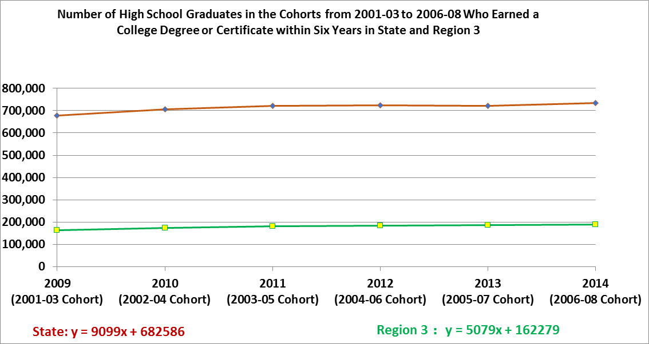
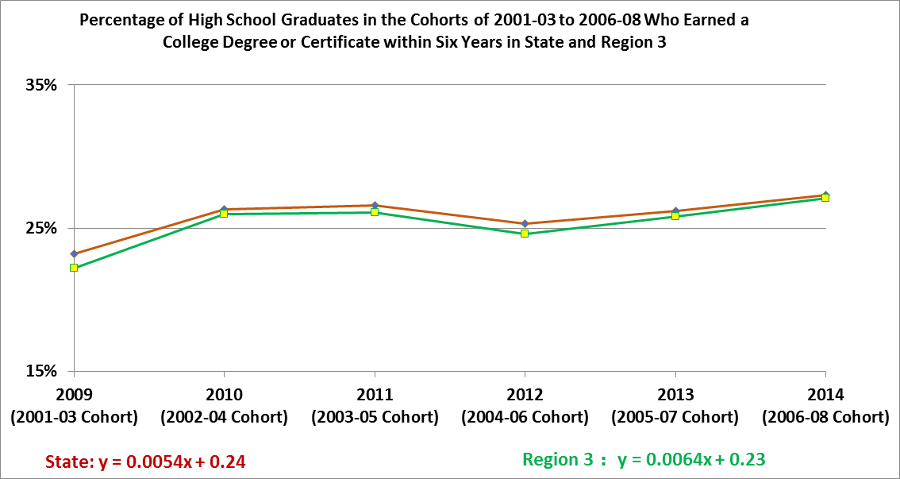

Employment Rate and Average Wage in 4th Quarter for First Time in College (FTIC) Graduates of 2-year Colleges in State and North Texas

Year/Δ | State 2-year Colleges |  |  |  |  | North Texas 2-year Colleges
 | Total Graduates | All Working | 4th Qtr  Employment Rate | 4th Qtr  Mean Wage |  | Total Graduates | All Working | 4th Qtr  Employment Rate | 4th Qtr  Mean Wage
2014 | 101,267 | 69,925 | 69.05% | $8,079 |  | 20,676 | 14,659 | 70.9% | $8,581
2013 | 92,888 | 65,545 | 69.5% | $7,779 |  | 18,962 | 13,200 | 69.6% | $8,016
2012 | 84,763 | 57,488 | 67.8% | $7,198 |  | 13,806 | 9,368 | 67.9% | $7,669
2011 | 78,898 | 53,312 | 67.6% | $7,093 |  | 12,505 | 8,570 | 68.5% | $7,535
2010 | 70,209 | 47,902 | 68.2% | $7,320 |  | 12,147 | 8,315 | 68.5% | $7,804
2009 | 61,155 | 42,614 | 69.7% | $7,541 |  | 10,393 | 7,295 | 70.2% | $8,032
Δ | 9.0% | 6.7% | .45% | 3.9% |  | 9.0% | 11.1% | 1.3% | 7.1%
MARC | 14.5% | 15.1% | 0.02% | 1.7% |  | 28.1% | 29.8% | 0.2% | 1.3%
(Source: THECB – Gainful Employment –Placement Rate)
Note 1: Δ = Change from 2013 to 2014; MARC = Mean Annual Rate of Change from 2009 to 2014
Note 2: The MARC for the total graduates, the number of all-working, or the mean wage is calculated as the ratio of the slope over the intercept of the linear equation, respectively.
Note 3: The numbers are for all majors and all degrees/certificates.
Note 4: The annual average wage was not reported since 2009. However, 4th Qtr employment ratio and 4th Qtr mean wage have been consistently reported since then and were selected for analysis.
Note 5: North Texas 2-year colleges include Collin College, Dallas County Community College District, North Central Texas College, and Tarrant County College.
Note 6: Starting from 2010, the Trinity River campus is included in the Tarrant County College.

Employment Ratio and Average Wage in 4th Quarter for First Time in College (FTIC) Graduates of 4-year Colleges from 2009 to 2014 in State and North Texas
Year/Δ |  | State 4-Year Colleges |  |  |  |  |  |  |  | North Texas 4-Year Colleges
 |  | Total Graduates |  | All Working |  | 4th Qtr  Empl. Rate | 4th Qtr  Mean Wage |  |  | Total Graduates | All Working | 4th Qtr  Empl. Rate | 4th Qtr  Mean Wage
2014 |  | 141,105 |  | 99,255 |  | 70.3% | $11,633 |  |  | 32,990 | 23,992 | 72.7% | $12,215
2013 |  | 136,651 |  | 97,714 |  | 71.5% | $11,290 |  |  | 32,077 | 23,556 | 73.4% | $11,658
2012 |  | 129,203 |  | 92,081 |  | 71.3% | $10,484 |  |  | 30,200 | 22,106 | 73.2% | $10,894
2011 |  | 123,998 |  | 87,649 |  | 70.7% | $9,857 |  |  | 27,903 | 20,577 | 73.7% | $10,325
2010 |  | 118,609 |  | 84,832 |  | 71.5% | $9,894 |  |  | 25,575 | 18,835 | 73.6% | $10,141
2009 |  | 114,582 |  | 82,831 |  | 72.3% | $9,898 |  |  | 24,860 | 18,577 | 74.7% | $10,003
Δ |  | 3.3% |  | 1.6% |  | 1.2% | 3.0% |  |  | 2.8% | 1.9% | 0.7% | 4.8%
MARC | 5.1% |  | 4.6% |  | 0.3% |  |  | 4.2% |  | 7.9% | 7.2% | 0.3% | 5.0%
(Source: THECB – Gainful Employment – Placement Rate)
Note 1: Δ = Change from 2013 to 2014; MARC = Mean Annual Rate of Change from 2009 to 2014
Note 2: The MARC for the total graduates, the number of all-working, or the mean wage is calculated as the ratio of the slope over the intercept of the linear equation, respectively.

Note 3: North Texas 4-year colleges include Tarleton State University, Texas A&M - Commerce, Texas Woman’s Univ., University of Texas at Arlington, University of Texas at Dallas, University of North Texas, and University of North Texas at Dallas. Starting from 2013, the data for University of North Texas at Dallas has been available and included.
Note 4: The statistics are based on graduates of associate, bachelor, master, and doctorate degrees and bachelor-level and graduate-level certificates.

FAFSA Submission and Completion Rates in 2015 and 2016 in State and Regions 10 and 11

Year | State |  |  |  |  | ESCs 10 and 11
 | Senior Counts | Submission % | Completion % | Incompletion % |  | Senior Counts | Submission % | Completion % | Incompletion %
2016 | 318,822 | 52.77% | 49.16% | 3.61% |  | 85,955 | 52.35% | 48.38% | 3.97%
2015 | 308,922 | 53.05% | 49.25% | 3.80% |  | 83,882 | 53.55% | 49.44% | 4.11%
Δ | 3.11% | 0.53% | 0.09% | 0.19% |  | 2.41% | 2.29% | 1.06% | 0.14%
(Source: Personal Communications with Dr. Denise Davis at Communities Foundation of Texas)
Note: Δ = Change from 2015 to 2013

