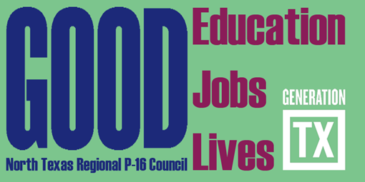
North Texas Regional P-16 Council Meeting
University of North Texas Dallas
Building #2 (new building) Room 308
September 16, 2010 9:30 – 11:30 am

- Welcome and Introductions Jean Keller

- North Texas Regional P-16 Council History Mary Harris

- North Texas Regional P-16 Council Present Jean Keller

- Why Me? North Texas Regional P-16 Council
Members – Roles and Responsibilities Francine Holland

- North Texas Regional P-16 Council Future –
Strategic Plan Jean Keller

- The Future Will Be Created by You
- Communications and Networking – Brenda Kihl & Cynthia Fisher Miller
- Professional Development – Barbara Lerner & Jesse Jones
- Funding and Sustainability – Mary Harris, Don Perry, & Ray de los Santos
- Research, Assessment, & Accountability – Barbara Bush & Francine Holland

- Committee Assignment & Work – Council Members
Select Committee Membership Brenda Kihl

Future Council Meetings
December 2, 2010 9:30 – 11:30am Education Service Center Region XI
February 17, 2011 9:30 – 11:30am Texas Woman’s University
May 5, 2011 9:30 – 11:30am Education Service Center Region XI

