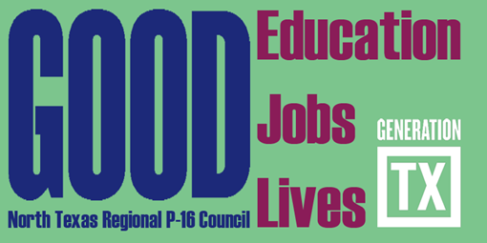
http://ntrp16.org/

North Texas Regional P-16 Council Meeting Agenda DRAFT
December 1, 2015 9:00 am – 12:00 pm

Education Service Center Region 11
1451 S Cherry Ln, White Settlement, TX 76108
Phone: (817) 740-3600
http://www.esc11.net/Page/5874 for directions

- Greetings, Introductions and Refreshments (9:00– 9:10) Jean Keller
Welcome and thanks to Education Service Center 11 Kathy Wright-Chapman

- Updates and Announcements from Council Members (9:10 – 9:35)

- Updates on AVATAR and GenTX (9:35- 9:50) Mary Harris

- Gap Analysis Report and Accountability Measures (9:50 – 10:05) V. Barbara Bush

- Program (10:05– 11:10)
Career Pathways - K-12 and Beyond
(Facilitators: Cynthia Miller and Don Perry)

- Committee Meetings and Brief Reports of Action Plans for 2015-2016 (11:10-12:00)
1. Communications & Networking & Social Media – Jeffrey Miller & Jann Miles
2. Funding & Sustainability – Don Perry & Ray de los Santos
3. Professional Development – Barbara Lerner & Kathy Wright-Chapman
4. Research, Assessment, & Accountability – V. Barbara Bush

- Adjourn

Update Your Calendars for 2015-16 NTRP-16 Council Meeting Dates and Programs
9:00am – 12:00 pm
Date | Place | Host | Topics | Program Leader
February 16, 2016 | ESC 10  Abrams Facility, Brazos Room | Chris Kanouse | Full Service Education and Students and Families | Kathy Wright-Chapman, Jeff Miller, & Kristin Herbert
May 3, 2016 | Educate Texas | Denise Devora & Denise Davis | THECB 60x30 Strategic Plan – Marketability Skills | Barbara Lerner & Dani Day

