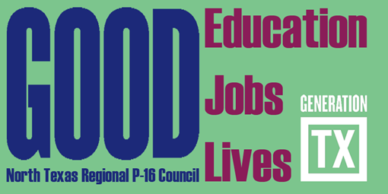
http://www.ntp16.notlb.com/

North Texas Regional P-16 Council Meeting Agenda
December 2, 2014 9:00 am – 11:00 am
Fort Worth Chamber of Commerce
777 Taylor Street, 12th Floor (Fort Worth Club)
Fort Worth, TX 76102

.

- Greetings, Introductions and Refreshments (9:10– 9:25) Jean Keller
Thank you to the Fort Worth Chamber of Commerce

- Approval of the September 16, 2014 Minutes

- Gap Analysis Report and Accountability Measures (9:25 – 9:40) V. Barbara Bush

- Program ( 9:45– 10:45)
“V. Barbara and Reo will provide title and speakers" Panel Discussion?

- Committee Meetings and Reports (10:45-11:10)
- Communications & Networking & Social Media – Cynthia Fisher Miller, Jeffrey Miller, & Debbie Endres
- Funding & Sustainability – Don Perry, Ray de los Santos
- Professional Development – Barbara Lerner
- Research, Assessment, & Accountability – V. Barbara Bush

- Updates and Announcements from Council Members (11:10 -11:30)

- Adjourn and Happy Holidays

Mark Your Calendars for the 2014 – 2015 NTRP-16 Council Meetings
9:00am – 12:00 pm
February 17, 2015 | Educate Texas-Dallas | Host: Reo Pruiett | Topic: Legislature Update | Meeting Leader: Cynthia Fisher Miller & Lanet Greenhaw
May 5, 2015 | Grand Prairie ISD | Host: Jeffrey Miller | Topic: College Preparatory Courses and AVATAR | Meeting Leader: Chris Kanouse, Kathy Wright-Chapman, & Dana Grieb

