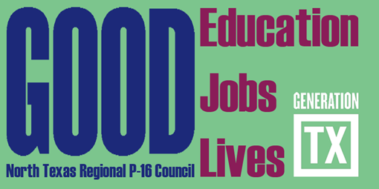
http://ntrp16.org/

North Texas Regional P-16 Council Meeting Agenda

February 7, 9:00 am – 12:00 pm

Fort Worth Chamber, 306 West Seventh Street, Fort Worth, TX 76102
Room: Top O’ the Town – 12th Floor

- Greetings, Introductions and Refreshments (9:00– 9:10) Jean Keller
Welcome and thanks to Fort Worth Chamber

- Regional Data (9:10-9:30) V. Barbara Bush

- Moving Texas Students Forward: An Examination of Texas Education Legislative Topics (9:30 – 10:30)
Program Moderators: Cynthia Miller & Pam Brown
Panelists: Dr. Susan Hull, Superintendent, Grand Prairie ISD
Lanet Greenhaw, Vice President, Education, Dallas Regional Chamber
David Saenz, CTE Director, Forth Worth ISD
D. Discussion, Reflections, and Actions (10:30-11:00) Christine Hubbard
E. Updates and Information Sharing (11:00-11:30) All Council Members
F. Committee Reports (11:30-11:50)
1. Communications & Networking & Social Media – Jann Miles, Jeffrey Miller and Fred
Schmidt
2. Funding & Sustainability – Don Perry & Ray de los Santos
3. Professional Development – Pam Brown, Michelle Buggs & Barbara Lerner
4. Research, Assessment, & Accountability – V. Barbara Bush & Raul Martinez

G. For Council Members Review, Suggestions, and Approval

2016-17 NTRP-16 Council Meeting Dates and Programs - 9:00am – 12:00 pm
Date | Place | Host | Topics | Program Facilitator
May 9, 2017 | Preston Ridge Campus  PRC Conference Center - Section C  9700 Wade Blvd. Frisco, TX 75035 | Raul Martinez | 60X30TX Update | Raul Martinez, Barbara Lerner, & Michele Buggs

H. Adjourn

