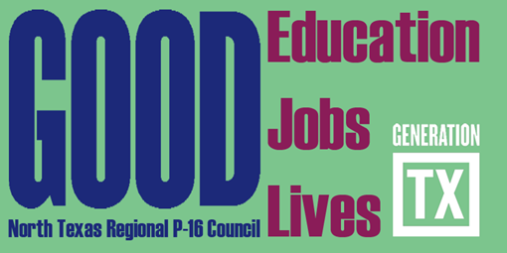
DRAFT
http://www.ntp16.notlb.com/
North Texas Regional P-16 Council Meeting Agenda
December 4, 2012 - 9:00am- 12:00pm
Region XI Education Service Center
3001 North Freeway Fort Worth, Texas 76106
817-740-3600

A. Greetings and Refreshments – 9-9:15am

B. Welcome and Introductions – 9:15-9:30am
Thank you to Dr. Francine Holland and Region XI Education Service Center for hosting the NTRP-16 Council.

C. Approval of September 18, 2012 Minutes

D. GenTX Marketing Grant Mary Harris

E. TG Financial Literacy Program – 10-10:30am Nancy VanBoskirk TG Financial Literacy Consultant

F. Updates and Announcements from Council Members 10:30-10:45am All

G. Break and Meet a New Friend – 10:45-11am

H. Gap Analysis Report - 11-11:15am V. Barbara Bush & Cynthia Williams

I. The State of the Region Conference- 11:15-11:30am Rick Garcia, Don Perry &
Reo Pruiett

I. Committee Reports (5 minutes each) – 11:30-12:00pm

*Communications and Networking Cynthia Fisher Miller
*Professional Development Barbara Lerner
*Funding and Sustainability Mary Harris
*Research, Assessment, and Accountability V .Barbara Bush

M. Adjourn and Complete Your Committee Assignments - 12:00pm All

Future Council Meetings
(All Meetings are from 9:00-Noon)

February 19, 2013 - Dallas County Community College District, Dallas - Host, Don Perry
May 7, 2013 – Fort Worth Chamber of Commerce, Fort Worth - Host, Cynthia Fisher Miller

Proposed Executive Committee Meetings (Please Confirm)
9:00am-Noon

January 15, 2013 Education Service Center XI Francine Holland
April 2, 2013 Texas Woman’s University Barbara Lerner
June 4, 2013 Fort Worth Chamber of Commerce Cynthia Fisher Miller
August 6, 2013 University of North Texas V. Barbara Bush

