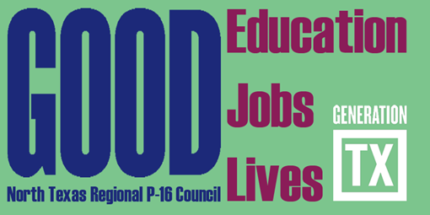
North Texas Regional P-16 Council Meeting
December 2, 2010, 9:30 – 11:30 a.m.
Region XI Education Service Center
1300 North Freeway, Ft. Worth, TX
Conference Room 2
Present:
Judy Bell, Patricia Castillo, Pan Ehrich, Cynthia Fisher Miller, Rick Garcia, Mary Harris, Francine Holland, Jesse Jones, Marilyn Jones, Jean Keller, Brenda Kihl, Amy Klohn, Calvin Lawrence, Barbara Lerner, Sandy Maddox, Mike Mattingly, Danielle Mazzeo, Marie Morris, Christie Myers, Don Perry, Ray de los Santos, David Setzer, John Shellene, Candy Slocum, Donna Solley, Jeannie Stone, Cynthia Williams

- Welcome and Introductions

Greetings and welcome to Region Xi ESC from Dr. Francine Holland. Dr. Holland was thanked for the warm hospitality.

- Approval of September 16, 2010 Council Minutes

Francine Holland moved for approval. Don Perry seconded. Motion approved.

- Marketing Class Project Overview – GenerationTX

The UNT College of Business Executive MBA program marketing class adopted the Generation TX peoject for the Fall 210 semester. Melody Linch. Karina Shivdasani, Kristen Serrano, and Cristina Valdez presented on Generation TX. See http://gentx.org

- State P-16 Institute Review

Francine Holland and Barbara Lerner reported the following topics were discussed at the Institute: generation TX; dropout prevention/college and career readiness initiatives; STEM initiatives; early college high schools; TG public grant competition; fathers active in the communities and education; feria para aprender; and comprehensive student success initiatives.

Council members were invited to participate in the February 1 and 2, 2011 State P-16 Institute.

- Career and Technical Education Marketing Project

Don Perry updated council members on a project entitled “Career and Technical Education: Texas Genuine”. Discussion was facilitated on linking community college technical degrees and bachelor’s in Applied Arts and Sciences (BAAS). Additional information about the project will be available in the near future.

- Achieving Council Goals and Objectives – Workgroup/Committee Reports

Communications and Networking – Brenda Kihl and Cynthia Fisher Miller reported on the committee’s last meeting and shared the draft newsletter. All were excited about the newsletter. Information regarding using the Gen TX website to post public college and career going events were discussed. The committee will be evaluating the NTRP-16 Council’s website and making recommendations for improvement.
Action Item: Committee will set outcomes related to newsletter publication and website update.

Professional Development – Barbara Lerner and Jesse Jones shared a late spring counselor college and career readiness meeting is being planned with the Educational Service Centers Region 10 and XI. Cynthia Fisher Miller shared ideas from the joint Fort Worth Chamber Education and Workforce Committees on a career fair idea. On December 10, 2010, a college and career readiness sciences planning meeting is being hosted by the Council and the College and Career Readiness Special Advisors in the North Texas region related to Biology, Chemistry, and Physics. A mathematics curriculum alignment meeting is set for early spring 2011.
Action Item: Committee will set outcomes related to College and Career Workshop with Counselors and a major event, possible a career fair.

Funding and Sustainability – Mary Harris, Don Perry, and Ray de los Santos updated the Council on plans to write letters of support for any Council member organization applying for the funds that support the Council’s mission and vision. Council members were supportive of the concept and requested information on how this good idea could be implemented. The committee will bring a proposal to Council’s Executive Committee for action on January 13, 2011.
The committee will explore submitting a capacity building grant to the TG Grant Program. Letters of Intent are due in January. Mary Harris and Jean Keller will work with the committee on a submission.
Action Item: Committee will set outcomes related to TG Grant Program submission and implementation plan for preparing letters of support.

Research, Assessment, and Accountability – Francine Holland discussed the conference call her committee members has exploring the Gap Analysis and trend data and how this information can be disseminated and used to make sound decisions by the Council and others. The committee will report at the February 17, 2011 Council meeting.
Action Item: Committee will set outcomes related to presenting the Gap Analysis information to Council members on February 17, 2011 and how to disseminate and use the data.

Future Council Meetings
February 17, 2011 9:30 – 11:30am Texas Woman’s University

May 5, 2011 9:30 – 11:30am Education Service Center Region XI

