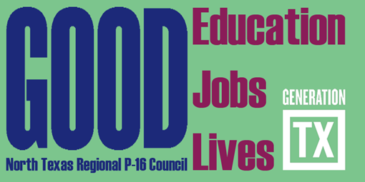
http://www.ntp16.notlb.com/
North Texas Regional P-16 Council Meeting Minutes
September 18, 2012 - 9:00am- 1:30pm
Communities Foundation of Texas,
5500 Caruth Haven Lane, Dallas, TX 75225

A. Welcome and Introductions Jean Keller

B. Capital One Bank University Crossroads Education Center Brenda Kirby
C. TxCAN/Educate Texas Danielle Mazzeo
D. Commit! Jonathon Feinstein
E. Updates and Announcements from Council Members
F. Approval of May 8, 2012 Council Meeting Minutes
G. The State of the Region Conference Rick Garcia, Reo Pruiett,
Don Perry

H. Gap Analysis Cynthia Williams
I. AVATAR Mary Harris

Future Council Meetings
(All Meetings are from 9:00-Noon)

December 4, 2012 - Education Service Center Region XI, Fort Worth - Host, Francine Holland
February 19, 2013 - Dallas County Community College District, Dallas - Host, Don Perry
May 7, 2013 – Fort Worth Chamber of Commerce, Fort Worth - Host, Cynthia Fisher Miller

Proposed Executive Committee Meetings (Please Confirm)
9:00am-Noon

November 6, 2012 Communities Foundation of Texas Reo Pruiett
January 15, 2013 Education Service Center XI Francine Holland
April 2, 2013 Texas Woman’s University Barbara Lerner
June 4, 2013 Fort Worth Chamber of Commerce Cynthia Fisher Miller
August 6, 2013 University of North Texas V. Barbara Bush

