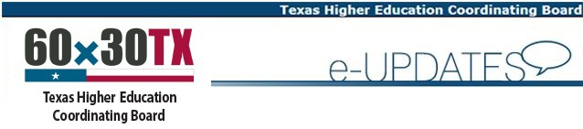Having trouble viewing this email? View it as a Web page.

Reminder about TSI Assessment Benchmarks
THECB recently approved an amendment to TSI rules to remove all language related to “phase-in” scores of the TSI Assessment (TSIA) college readiness benchmarks. Instead, we are awaiting the results of the TSIA validation study to help determine whether the college readiness benchmarks will change. Once recommendations are made, there will be a 30-day public comment period with the board making its final consideration for approval at its summer meeting.
Meanwhile, please note that the benchmarks in place on the date a student tests are the ones that should be used to determine that student's college readiness. For example, if a student tests today on the TSIA-math portion and scores a 350, that student is considered college ready in math. Students should not be directed to retest if they have met the current college readiness benchmarks since TSIA results are valid five (5) years from date of testing. Please ensure all TSI testing personnel, counselors, advisors, and other applicable support staff are immediately informed of this policy.

Questions About This Update?
Contact Kathy at Kathy.Zarate@thecb.state.tx.us.
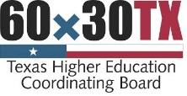 |  | Questions? Contact us  How are we doing? Customer Satisfaction Survey

GET UPDATES:
SUBSCRIBER SERVICES:
This email was sent to jean.keller@unt.edu using GovDelivery, on behalf of: the Texas Higher Education Coordinating Board · 1200 E. Anderson Lane, Austin, TX 78752

